[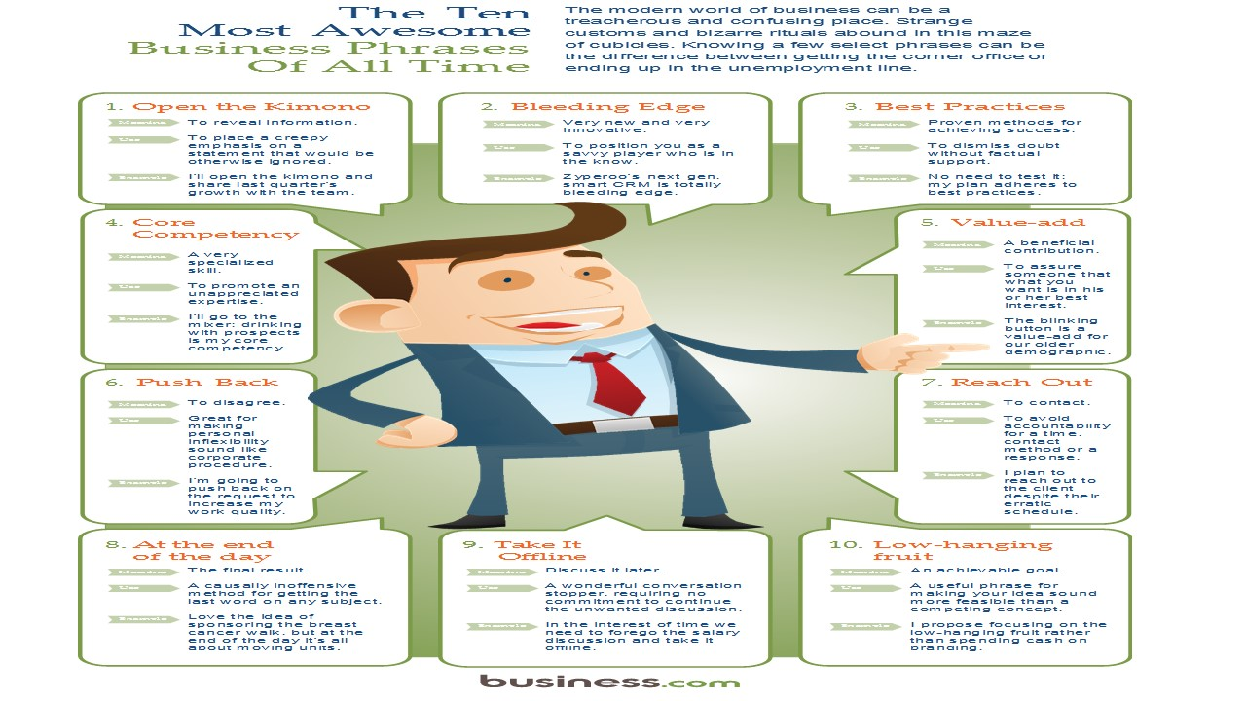](YELD%20HEADER/RP%20Business%20jargon.jpg)